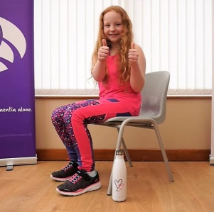
The Challenge: To participate in an exercise session carried out via live Social Media call hosted by 9 year old Heather.
100 Care Homes on one session.

Name of person being sponsored: _________________________________________ Date of Challenge: 11th June, 2021
Sponsorship Form
I’m raising funds for: ______________________________________
Sponsor’s  Full Name | Home  Address | Postcode | Amount  Donated | Paid  (Yes/No)

